Air Powered Rover

Subject: Physics, Mechanical Engineering, Electronics  Related Subjects: Mechanical advantage, motion, electricity, friction, torque | Grade Level(s):  Length of Lesson: | Type: Inquiry / Design / Project  Keywords: Series circuit, axle, chassis, alignment, horsepower (torque x rpm), suspension

Lesson Overview
Each student will create a chassis, wheels, and an electrical circuit in a car that actually works!
Students will then test cars for speed, distance and endurance.

Lesson Focus
What is the central question or phenomenon being investigated? What problem are they trying to solve?

Lesson Objective(s) | • Students build suspension (wheels and axles) from bottle caps, foam core and wood dowels.  • Students build chassis from foam core.  • Students create series circuit with motor, batter holder and switch  • Students assemble USC rover.  • Students determine which design leads to better performance in  - • Speed  - • Direction  - • “Off road” conditions  • Students will also demonstrate trade-off of beauty versus function

Lesson Timing

5 minutes | Introduce the Lesson
30 minutes | ...

Materials | - Foam board  - 2. Wood skewers  - 3. Two straws  - 4. 3⁄8” wood dowels (one 3 inches)  - 5. Four caps from small water bottles  - 6. 1.5V motor  - 7. Battery holder (double AA battery  - holder)  - 8. Two AA battery  - 9. Brass plated fasteners (1 inch)  - 10. Insulated wire  - 11. Hot Glue gun  - 12. Hot glue sticks  - 13. Large paper clips  - 14. Wire stripper  - 15. Xacto knife or utility knife (to cut foam  - board)  - 16. Drill  - 17. Propeller
Instructor Prep | - Step 1
Related Resources | - List related lessons/ppts etc available from USC or outside, trusted orgs

Lesson Plan

Introduction

Anyone who has been on a bike or in a stick shift car has felt the effects of gearing and

mechanical advantage causing motion. Some energy source (your legs or a motor) causes an

object to turn. That object turns another object causing the vehicle to move forward.

Procedure
–Cut a rectangle from the foam core (team decides on size).
2. –Cut two 1⁄2” slits into the foam core parallel to the side railings (about 2” from one of the
railings and about 1” apart).
3. –Cut two straws (team decides on length).
4. –Drill a hole in the middle of each of the four water bottle caps (the circumference smaller
than the circumference of the wood skewer).
5. –Glue the two straws to foam core parallel (for axles).
6. Insert one end of the skewer into one of the water bottle caps. Insert axle into the straw. And
insert other end of skewer into second water bottle cap.
7. Repeat above for second axle.
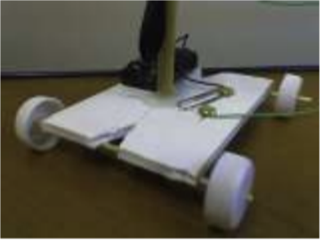

Instructions for battery-powered Propeller
1. –Cut and strip one piece of wire (about 6”).
2. –Strip both wires of a battery holder.
3. –Insert one end of the 6” wire to one lead of motor.
4. –Insert one wire of battery holder to second lead of motor.
5. –Tape both wires to motor.
6. –Using the other end of the 6” wire, insert stripped wire between the legs of a brass fastener
and secure. Insert the brass fastener with wire into one of the slits and fasten to the foam
core.
7. –Using the other wire from the battery holder, insert the stripped wire between the legs of
another brass fastener and secure. Insert brass fastener into paper clip, insert into second slit,
and fasten to foam core.
8..–Attach propeller to the stem of motor
9. –Test circuit with batteries.
10. –Cut one piece of 3⁄8”dowel (team decides on length).
11. –Glue motor with attached propeller to one end of the dowel.
12. –Glue other end of the dowel to the foam core (team decides on location).
13. –Glue battery holder to foam core.
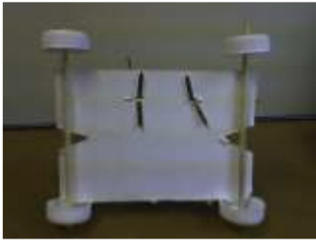

Wrap-up
• Students compete for speed, direction, and obstacles run over to determine the effect of
suspension, chassis design, propeller placement, wheel placement and alignment have on
motion, friction, and horsepower.

Lesson Background for Teachers

Suggested Real-World STEM Connections
- List possible related Role Models in STEM (with details and links to more reading). Give suggestions for examples of scientists/engineers who are from underrepresented groups in STEM in related careers.
- List related real-world engineering problems and examples

Lesson Variations and Options
Include descriptions of alternative methods or ways to present things.

Explanation
The suspension of the rover comprises two straws, two wood skewers and four small water
bottle caps. Each wood skewer is inserted lengthwise through the straw with a foam core wheel
base attached to each of the straws. A tight suspension involves a tight fit through the foam core
base for the dowel. A loose suspension allows wiggle room for the dowel inside the foam core
base.
The chassis of the rover has to be:
1. Sufficiently thick to carry the weight of the motor, switch, and battery holder.
2. Sufficiently long to accommodate front and back wheels.
3. Sufficiently sturdy to withstand the force of the propeller and wheels.
A series circuit is formed when an electrical source (battery) is connected to an object (motor,
light...) which is connected to a switch which is connected back to the battery.

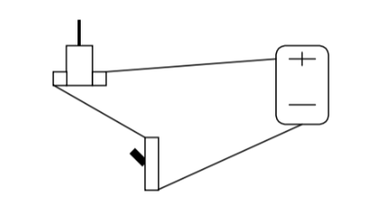

When the switch is off, the circuit is open and electricity can’t flow. When the switch is on, the
circuit is closed and electricity can flow.
The variables to this design are in chassis length and width, suspension, and placement of the
propeller.

Key Concepts and Vocabulary
- Word 1: Grade Appropriate Definition
- Word 2: Grade Appropriate Definition

Safety Notes
- Caution should be exercised with cutting utensils (scissors, X-acto blade).
- Students should be careful with hot surfaces (glue gun, soldering iron).
- Proper safety procedures and equipment should be used for drill, drill press and belt sander.

